MUTI CARRIER PARCEL SOLUTION / TRANSPORTATION MANAGEMENT SYSTEM
- Business / Use Case
- The existing TMS is primarily utilized as a shipment execution and repository tool for NA Retail operations
- The initial integration scope was limited to an EBS order file, resulting in minimal use of shipment optimization capabilities
- The current TMS support team lacks deep industry knowledge, leading to missed context during discussions and misaligned performance metrics
- Data manipulation and reporting remain constrained due to full dependency on the TMS team for dashboard edits and report adjustments
- There is an opportunity through this request to expand the scope of support beyond Retail and explore improvements in eCommerce rate shopping, parcel optimization (currently setup as manual processes at the DC’s), as well as optimizing Routing processes

- Objective
  - Enable shipment optimization and rate shopping capabilities across both Retail and eCommerce channels to improve cost efficiency and delivery performance
  - Enhance operational alignment by leveraging support resources with deeper industry and transportation expertise for better decision making
  - Reduce manual effort across DC Wave Planning, Logistics Coordinators, and Logistics Analysts by eliminating current “process shadowing” required to verify task completion
  - Strengthen analytical self-service with improved visibility by empowering business users to access and manipulate reporting without dependency on the TMS support team

- OKRs (Objectives and Key Results)
  - Achieve reduction in transportation spend through automated rate shopping and mode optimization
  - Transition to a dedicated TMS support structure with defined roles and measurable SLAs quarter 1 after implementation
  - Decrease manual “process shadowing” tasks within the first 3 months
  - Deliver role-based dashboards and reporting access to 100% of Logistics and Finance stakeholders within the first 6 months
- ROI
  - Formal review of vendor offerings and pricing will vary on complexity and need, however initial guidance from Gartner consultants indicate pricing can range from 100-300k per year.

  - Gartner research indicates opportunities for savings and improved productivity across various areas of the business:
Source: Gartner (November 2021)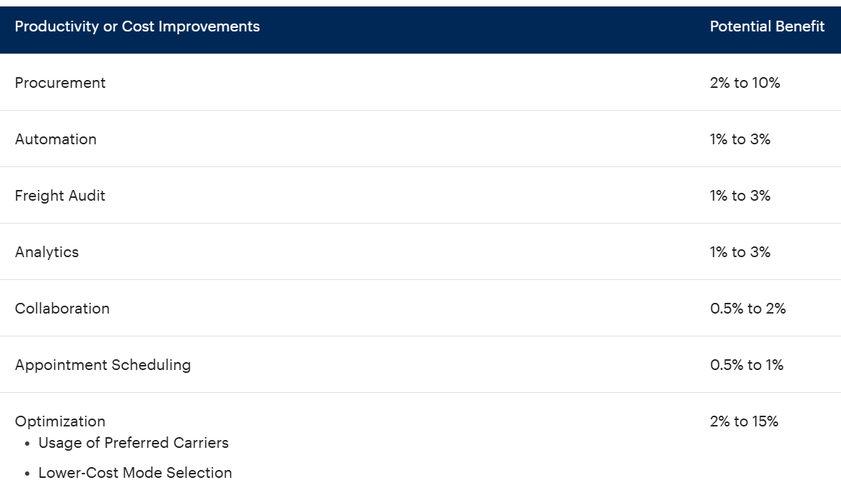
  - Our retail freight spend is +$10M a year and eCommerce parcel is +$150M a year. A conservative approach looking at freight spend alone and improved automated carrier optimization efforts that could yield 2% of annual savings, would equate to ~$3M USD
  - Return on Investment would be immediate with the right vendor selection
- Risk Mitigation & Impact
  - Existing TMS contract expires in March of 2026. NA Logistics would like to have internal alignment on internal next steps to possibly limit the length and scope of the contract as necessary
- Impacted Functional Areas
  - Logistics, Distribution Center (Wave Planning, Shipping, Routing), eComm Fulfillment, Finance, Retail Ops
- Call to Action
  - With an annual transportation spend exceeding $150M, a focused investment of less than 0.2% could unlock meaningful savings while advancing a more omnichannel, data driven shipping strategy that improves consistency and visibility across stakeholders
  - We request Digital and Data’s partnership to initiate this review, beginning with vendor exploration, assessment of benefits across regions, and definition of a preliminary execution timeline
  - As our TMS contract expires in under six months, timely alignment on renewal strategy and evaluation of alternative partners will be critical to capture these opportunities

